<http://linuxengines.blogspot.in/2012/04/squid-proxy-server-configuration.html>

Squid Server Interview Questions And Answers for Linux admin

**Q: - On Which port Proxy server work ? Can we change proxy server port ?**

By default proxy server runs on 3128 port. yes we can change proxy server port.

vi /etc/squid/squid.conf  
  
http\_port 3128

**Q: - How to block Some domains by Squid server ?**  
  
Make a file

vi /etc/squid/bad\_domains

.xxx.com  
.abcd.com  
.sexy.com

Now make following changes in Squid.conf file

acl BAD\_DOMAINS dstdom\_regex -i "/etc/squid/bad\_domains"  
http\_access deny BAD\_DOMAINS

**Q: - How to clear Cache in Squid proxy?**   
Firstly stop squid server.

service squid stop

rm -rf /var/lib/squid/cache/\*

squid -z

**Q: - How to restart squid server ?**  
  
service squid restart

**Q: - What is the name of main configuration file for Squid server ?**  
  
/etc/squid/squid.conf

**Q: - How to restrict web access by Time ?**  
  
acl MY\_TIME time M T W H F 9:00-17:00

http\_access allow MY\_TIME

**Q: - What is Squid ?**  
  
SQUID is a webcache and proxy server for Linux and UNIX.  
Users configure their web browsers to use the Squid proxy server instead of going to the web directly. The Squid server then checks its web cache for the web information requested by the user. It will return any matching information that finds in its cache, and if not, it will go to the web to find it on behalf of the user. Once it finds the information, it will populate its cache with it and also forward it to the user's web browser.

**Q: - What is location of Cache directories for SQUID ?**  
  
/var/spool/squid

**Q: - What this command "squid -z" will do ?**  
  
This command will create cache directories.

**Q: - Explain "maximum\_object\_size" directive?**

It defines maximum size for objects to be stored in the disk.The value are specified in kilobytes, and the default is 4MB.

**Q: - Explain "cache\_dir" directive?**

This is used to define cache directory, its path, type and size.

cache\_dir Type Directory-Name Mbytes Level1 Level2

**Q: - What is ufs?**

ufs is a squid storage format

## Squid Server Configuration Step By Step on Centos 5

Filed under: [Linux](http://siva2009.wordpress.com/category/linux/), [Squid](http://siva2009.wordpress.com/category/squid/) — [11 Comments](http://siva2009.wordpress.com/2010/06/26/squid-server-configuration-step-by-step-on-centos-5/#comments)

June 26, 2010

I recently configured squid server in Centos 5. I have shared my documentation with you all. Feedback’s are welcome.

**Squid Configuration File:**

/etc/squid/squid.conf

**Squid Access File Location:**

/var/log/squid/access.log

**Squid Error File Location:**

/var/log/squid/cache.log

**Viewing online Access log**

tail -f /var/log/squid/access.log |grep 192.168.1.124

**Configuration File**

acl all src 0.0.0.0/0.0.0.0

acl manager proto cache\_object

acl localhost src 127.0.0.1/255.255.255.255

acl to\_localhost dst 127.0.0.0/8

acl SSL\_ports port 443

acl Safe\_ports port 80 # http

acl Safe\_ports port 81 # Apache\_new

acl Safe\_ports port 21 # ftp

acl Safe\_ports port 443 # https

acl Safe\_ports port 70 # gopher

acl Safe\_ports port 210 # wais

acl Safe\_ports port 1025-65535 # unregistered ports

acl Safe\_ports port 280 # http-mgmt

acl Safe\_ports port 488 # gss-http

acl Safe\_ports port 591 # filemaker

acl Safe\_ports port 777 # multiling http

acl CONNECT method CONNECT

http\_access allow manager localhost

http\_access deny manager

http\_access deny !Safe\_ports

http\_access deny CONNECT !SSL\_ports

acl Allow\_url dstdomain “/etc/squid/custom/allowedurls”

acl goodsites dstdomain “/etc/squid/custom/goodsites”

acl goodsites\_ips src “/etc/squid/custom/goodsites\_dst\_ips”

acl jobsites\_ips src “/etc/squid/custom/jobsites\_dst\_ips”

acl download\_ips src “/etc/squid/custom/download\_dst\_ips”

acl emailallowip src “/etc/squid/custom/emailallowips\_dst\_ips” # for Geetha\_System

acl allallowip src “/etc/squid/custom/allallowips\_dst\_ips”

acl dlds urlpath\_regex -i \.gz \.msi \.rm \.asf \.mp4 \.mpa \.cab \.mp3 \.rm \.ram \.mepg \.mpg \.exe \.dll \.chm \.iso \.rar \.zip \.flv \.torrent

acl jobs dstdomain “/etc/squid/custom/job-sites.acl”

acl social dstdomain “/etc/squid/custom/social-sites.acl”

acl porn dstdomain “/etc/squid/custom/porn-sites.acl”

acl proxy1 dstdomain “/etc/squid/custom/proxy-sites.acl”

acl hack dstdomain “/etc/squid/custom/hack-sites.acl”

acl fileupload dstdomain “/etc/squid/custom/file-upload.acl”

acl email1 dstdomain “/etc/squid/custom/email-sites.acl”

http\_access allow localhost

#http\_access deny GeneralSites

http\_access deny jobs !jobsites\_ips

http\_access deny social !allallowip

http\_access deny porn

http\_access deny proxy1

http\_access deny hack

http\_access deny fileupload !allallowip

http\_access deny email1 !emailallowip

http\_access deny dlds !download\_ips

http\_access allow Allow\_url

http\_access allow goodsites goodsites\_ips

http\_access allow all

http\_access deny all

http\_port 3128 transparent

icp\_port 3130

cache\_mem 16 MB

cache\_dir ufs /var/spool/squid 100 16 256

access\_log /var/log/squid/access.log squid

cache\_log /var/log/squid/cache.log

cache\_store\_log /var/log/squid/store.log

visible\_hostname net.minthomes.server

**Restarting squid Service**

# Service squid restart or /etc/init.d/squid restart

# Service squid reload or /etc/init.d/squid reload

****Q: - On Which port Proxy server work ? Can we change proxy server port ?****

By default proxy server runs on 3128 port. yes we can change proxy server port.  
vi /etc/squid/squid.conf  
http\_port 3128

**Q: - How to block Some domains by Squid server ?**

Make a file

vi /etc/squid/bad\_domains

.xxx.com  
.abcd.com  
.sexy.com

Now make following changes in Squid.conf file  
acl BAD\_DOMAINS dstdom\_regex -i "/etc/squid/bad\_domains"  
http\_access deny BAD\_DOMAINS

**Q: - How to clear Cache in Squid proxy?**

Firstly stop squid server.  
service squid stop  
rm -rf /var/lib/squid/cache/\*<  
squid -z

**Q: - How to restart squid server ?**

service squid restart

**Q: - What is the name of main configuration file for Squid server ?**

/etc/squid/squid.conf

Q: - ****How to restrict web access by Time ?****

acl MY\_TIME time M T W H F 9:00-17:00  
shttp\_access allow MY\_TIME

****Q: - What is Squid ?****

SQUID is a webcache and proxy server for Linux and UNIX.  
Users configure their web browsers to use the Squid proxy server instead of going to the web directly. The Squid server then checks its web cache for the web information requested by the user. It will return any matching information that finds in its cache, and if not, it will go to the web to find it on behalf of the user. Once it finds the information, it will populate its cache with it and also forward it to the user's web browser.

**Q: - What is location of Cache directories for SQUID ?**

/var/spool/squid

Q: - ****What this command "squid -z" will do ?****

This command will create cache directories

Here the steps to PAM Authentication for squid proxy server. We are going to use the **pam\_auth** module.   
This will allow anyone who has a Linux or Unix shell account, will be able to use the Squid server  
  
  
To configure PAM Authentication, Edit the **/etc/squid/squid.conf** file:  
  
  
Search for the **auth\_param** section in the config file and add or uncomment these lines:  
  
  
  
*auth\_param basic program /usr/lib/squid/pam\_auth  
auth\_param basic children 5  
auth\_param basic realm Squid proxy-caching web server  
auth\_param basic credentialsttl 2 hours*

Next, search for the following line and uncomment it:  
  
  
*acl password proxy\_auth REQUIRED*

Now create a pam module called /etc/pam.d/squid and add the following lines to that module file.

*auth required /lib/security/pam\_unix.so  
account required /lib/security/pam\_unix.so*

Finally, Restart the squid :   
  
  
*service squid restart or /etc/init.d/squid restart*  
  
  
Thats all... You are done.. Now advise your users to use the UNIX/LINUX Passwords to access internet..

**Configure squid web proxy server**

**squid** rpm is required to configure squid web proxy server check it for install if not found install it.  
sqid rpm  
check the hostname and ip address of server it will be use in editing of squid.conf  
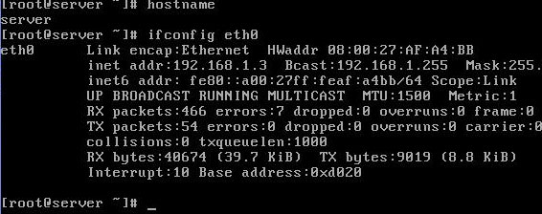

Main Squid configuration file is squid.conf in the /etc/squid/ directory. This file contains over 4000 lines in , but only a few are active by default. Most of this file is filled with comments that describe most directives and associated options. To make editing easier use show line numbers options and locate desire tag from line number. We suggest you not to cram line number use them only to locate the desire tag as a simple enter can change the number of all lines in file.

open /etc/squid/squid.conf for editing  
vi squid.conf  
show hidden line with : set nu option on vi command mode

You need to add three lines to the squid.conf file in the /etc/squid/ directory before activating Squid

First editing is about hostname locate visible\_hostname tag near about line no 2835  
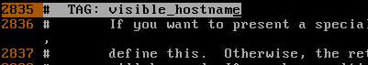  
Go in the end of this tag near about line no and add the hostname which you have checked in pervious command  
visible hostname

By default squid works on port no 3128 but can change this. Port tag is located near line no 73  
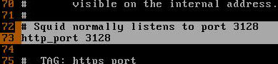  
For our example we using the default port.

Next editing is to create access control list. Access control tag is located near the line no 2226  
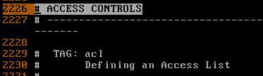

We will create three access list.

* First to block host with ip address 192.168.1.7 from accessing internet.
* Second to block a particular site.
* Third to allow our lab network for accessing internet.

Go in the end of access control tag near about line 2410 and create access list as show here  
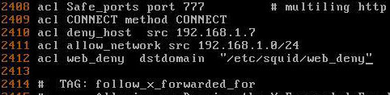

Final editing is to implement whatever access list you have configured in access list tag go to http access tag near line no 2482   
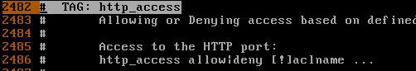  
In the end of this tag near line no 2529 apply the configured access list   
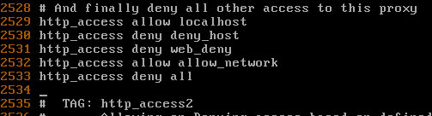

Be very careful about the order of access list alway put http\_access deny all line in the end of all line. Whatever access list defined below the http\_access deny all line will never be checked.

You have made necessary changed in squid.conf now save it and return to command prompt.

We have created a access list web\_deny to filter the web traffic. We have set http\_access deny web\_deny tag in squid.conf. Now you can add the url of those websites in this file which you want block.

Now create /etc/squid/web\_deny file.  
vi web_deny  
for testing purpose in our example we are blocking www.google.com   
editing in web deny  
you can add any sites url in this file which you want to block.

You have completed all necessary steps now start the squid service.  
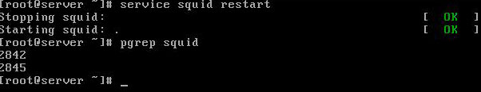

**Squid client configuration**

On client set the ip configuration. Set proxy servers ip 192.168.1.3 to default getway and dns server ip on client system.

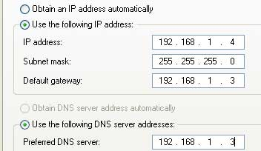

Now open the web browser and set the port number and ip address of proxy server in connection tab  
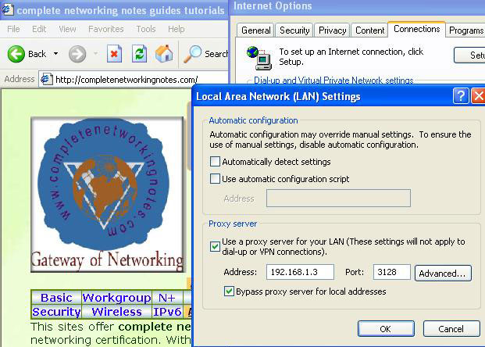  
If you can successful retrieve website mean squid is working correctly   
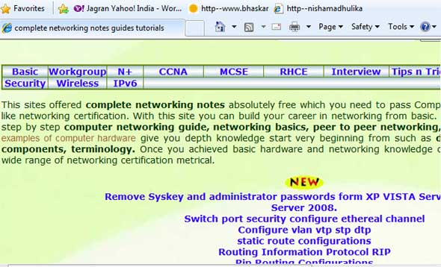

Now try to open www.google.com   
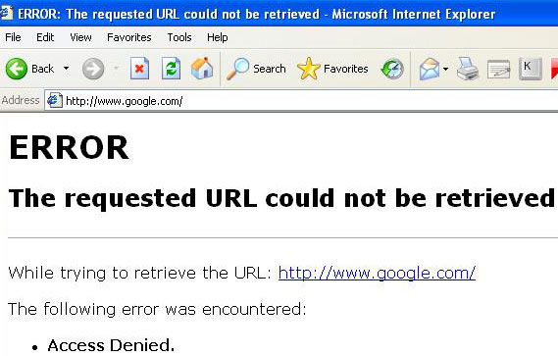

Now go system which ip address is 192.168.1.7 and try to access after doing same setting   
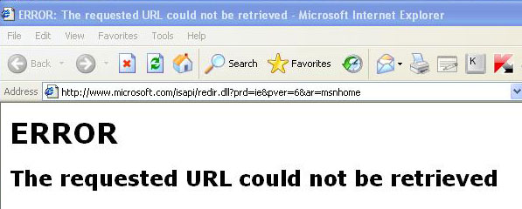

Below are the steps to setup the Squid Proxy Caching server on Red Hat Enterprise Linux

**1. Install Required Packages for Proxy Server:**

Install the "squid-2.5.STABLE14-1.4E" RPM packages on the server

**rpm -ivh squid-2.5.STABLE14-1.4E.rpm**

**2. Customize the squid.conf configuration file**

a. vi /etc/squid/squid.conf

**Configuring Squid File ( /etc/squid/squid.conf)**

Just Specify the details with respect to your requirements in squid.conf file. Look for the following lines…

*http\_port 8080*

*cache\_dir ufs /var/spool/squid 1400 16 256*

*cache\_access\_log /var/log/squid/access.log*

*cache\_log /var/log/squid/cache.log*

*cache\_store\_log /var/log/squid/store.log*

*dns\_nameservers [YOUR\_NAME\_SERVERS]*

*acl our\_networks src* [*192.168.1.0/24*](http://192.168.1.0/24)[*192.168.2.0/24*](http://192.168.2.0/24) *[ADD\_YOUR\_NETWORK\_ADDRESS\_HERE]*

*http\_access allow our\_networks*

*visible\_hostname [YOUR\_PROXY\_SERVER\_NAME]*

**3. Change the squid directory "/var/spool/squid/" to be owned by nobody**   
  
a. chown nobody /var/spool/squid/

b. chmod 700 /var/spool/squid/

**4. Run squid**

service squid start

<http://www.lazysystemadmin.com/2009/12/squid-proxy-caching-server-installation.html>

### 

### [Squid proxy server configuration](http://linuxengines.blogspot.in/2012/04/squid-proxy-server-configuration.html)

### [Squid proxy server configuration](http://linuxengines.blogspot.in/2012/04/squid-proxy-server-configuration.html)

1.SQUID PROXY  
BASIC  
TRANSPARENT SQUID PROXY  
CHILD SQUID PROXY

**WITHOUT SQUID**:  
==============  
ISP   
|  
|-----|SWITCH(Normal)|-----|---PC  
|---PC1  
|---PC2  
  
  
  
**SQUID PROXY:**  
=========

**use**: To share the internet through out the network with filter  
  
[ISP] (dhcp/static)  
|  
|  
[eth0]  
|  
\_\_\_\_\_\_  
| |  
| |  
| |--->(cache saved in /var/spool/squid)  
| | ........................  
-------- |  
| |  
| |.........................  
[eth1]--------[SWITCH]--|---[\_]-->...{www.google.com}  
|---[\_]  
|---[\_]  
|---[\_]  
  
**Profile:** It is use for to share the internet throughout the network with filter  
  
**Package:** squid, httpd  
  
**Port:** 3128(default ) **Demons**:squid  
  
**script:** /etc/init.d/squid  
  
**Configuration file:** /etc/squid/squid.conf

**Related:** ACL  
  
Service type: system-V-manage service  
 **To configure squid we Required:**  
  
-->PC with 2 NIC cards names eth0 and eth1  
-->ISP (internet public IP address) dhcp/static 51.73.171.26 provide to eth0   
  
check 3128 port is open or not   
  
#netstat -ntlp | grep 3128  
 **RULES in squid server**  
1. allow the network (eg: src )  
2. Deny the website (eg: dstdomain)  
3. Deny the Bad Words (eg: url\_regex)  
4. Time resoritation (eg: time)  
5. password Auth for MD (eg: proxy\_Auth)  
  
  
**STEPS to configure the SQUID PROXY**:  
========================  
  
step 1. install squid ,http packages  
  
#yum install squid\* http\* -y  
  
**step 2.Restart and enable services**  
  
#service squid restart  
#service httpd restart  
#chkconfig squid on  
#chkconfig httpd on  
  
**3.To allow the Network**  
==============  
  
go to squid configuration file, i.e,  
  
#vim /etc/squid/squid.conf  
  
1.search for word "http\_port" it is the squid listens port 3128 defalt( use /http\_port to search)  
  
2.search for word "INSERT" add below line  
  
acl mynet<rulename> src(keyword> 192.168.0.0/24  
  
http\_access allow mynet  
  
save and exit  
  
3. restart service  
  
#service squid restart  
  
  
**4.To deny website**  
============  
  
#vim /etc/squid/squid  
  
#INSERT your own RULES:

acl mynet src 192.168.0.0/24  
acl password proxy\_auth REQUIRED  
acl badsites dstdomain www.yahoo.com  
acl badtime time 10:00-16:00 #(10am to 4pm)  
acl badwords url\_regex -i "/etc/badwords" #(create file /etc/badwords and write all bad words)  
http\_access deny badwords badtime  
http\_access deny badsites  
http\_access allow password  
http\_access allow mynet  
  
 **To allowing users in bad time:**===================  
  
1.install a package htpasswd  
  
#yum install http\* -y  
2. To allow user called bob   
  
#htpasswd -mc /usr/etc/passwd bob  
  
3. search for word called ncsa and write the following  
  
auth\_param basic program /usr/lib/squid/ncsa\_auth /usr/etc/passwd

\*\*\*\*\*\*\*\*\*\*\*\*\*\*\*\*\*\*\*\*\*\*\*\*\*\*\*\*\*\*\*\*\*\*\*\*\*\*\*\*\*\*\*\*\*\*\*\*\*\*\*\*\*\*  
  
  
**SQUID TRANSPARENT CONFIGURATION:**=========================  
  
Please follow these steps you will configure the squid with  
  
#vim /etc/sysctl.conf  
  
net.ipv4.ip\_forward = 1  
  
save & quit  
  
#vim /etc/squid/squid.conf  
  
  
##--please enable this options--##  
  
  
http\_port 3128 transparent  
  
acl our\_network src 192.168.1.0/24  
  
http\_access allow our\_network  
  
cache\_mem 16M  
  
access\_log /var/log/squid/access.log  
  
cache\_log /var/log/squid/cache.log  
  
store\_log /var/log/squid/store.log  
  
cache\_dir /var/spool/squid 200016 256  
  
cache\_mgr user@desktop7.example.com  
  
visible\_hostname desktop7.example.com  
  
  
save and quit  
  
#squid -z  
  
#service squid restart  
  
  
#then if u want to make it transparent kindly add rules to iptable firewall##  
  
  
#iptable -t nat -A PREROUTING -p tcp -i eth0 --dport 80 -j REDIRECT --to-port 3128  
  
  
##If you would like to redirect the all http traffic through the proxy without needing to setup a proxy manually in all your applications you will need to add some rules,,  
  
  
#ipables -t nat -A PREROUTING -i eth1 -p tcp -m tcp --dport 80 -j DNAT --to-destination 192.168.0.1:3128  
  
  
#####......Note: eth0 is connected with your LAN switch.......##  
  
  
  
  
  
**CHILD PROXY CONFIGURATION:**==========================  
  
\_\_\_\_\_\_\_\_\_  
| |  
| |MAIN PROXY SERVER  
| |192.168.0.254  
| |  
| |  
| |  
-------------  
  
  
  
\_\_\_\_\_\_\_\_\_\_  
| |  
| |CHILD PROXY SERVER  
| |  
| |  
| |  
| |  
--------------  
  
#vim /etc/squid/squid.conf  
  
##search word for cache\_peer  
##uncomment following line

hostname type Proxy icp port options  
cache\_peer 192.168.0.254 parent 3128 3130 default  
  
#service squid restart